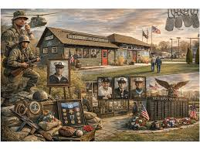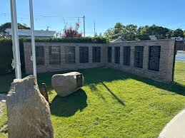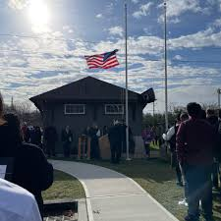
VFW Post 6249 Suffolk County World War II and Military History Museum Expansion Ceremony

Please join us for an exciting look at the newly created military history expansion on May 22nd at 10:30 am at 108A King Road, Rocky Point, NY, 11778. There will be refreshments before this event directly across the street from the museum at the Rocky Point VFW Post 6249. Come down for a nice morning of patriotism, service, and reflection towards the sacrifices that were made by our Armed Forces over the course of our national history.

Please contact Rich Acritelli at 631-839-2996 (richvack@yahoo.com) or Joe Cognitore at 631-873-8272
We hope to see you at this strong patriotic event.

